SQUARE DANCE
- Have Fun!
- Exercise Your
Brain and Body!
- Make New Friends!
Change these headings if you are reproducing in colour.
About Us!
Either insert a photo here with a brief description of your club,
OR
Use this area to tell prospective new dancers about your club. Some of the points to consider:
- How old is your club?
- What other interests’ do you club members pursue?
- Does your club sponsor benefit dances or support a charity or health cause?
- Profile your caller(s) and cuer(s)

It’s Easy to Learn!
No dancing experience required. “Two left feet”? – Not a problem!. You will learn and practice the steps along with everyone else. It’s a team effort.
Experienced square dance callers teach you the moves and the names of the calls that you dance. With practice, those moves will feel as natural as walking.
It’s a Social Event!
Square dancing just isn’t physical or mental – it has a great social aspect. It begins in a “square” with seven other new dancers. Dancers come together as a unit and share the fun of learning and doing. Laughter and camaraderie are natural by-products of people sharing a common passion.

It’s A Challenge!
Modern square dancing is a mental and physical challenge. It is dancing, it is thinking, it is teamwork! Moving in rhythm to music keeps you physically fit. Reacting quickly to the square dance caller’s calls keeps you mentally “on your toes”. And your team of eight dancers depends on you to keep those toes moving!

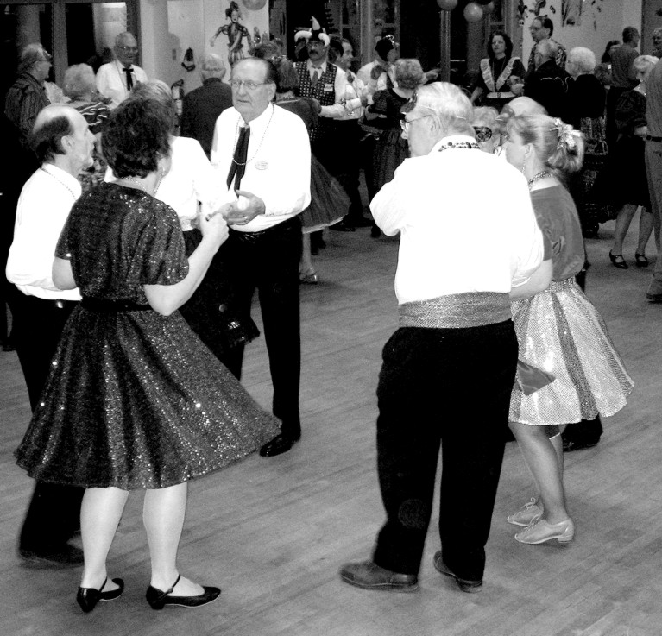

It’s a Party!
Square dancing is like a party. It brings people together for fun and friendship – even when learning how! Square dancing, a healthy exercise, is a workout for both the body and the brain.
The fun begins on the first night – which, by the way, is free to you for the first 2 sessions if you use the attached coupon. You meet other new dancers and gain new friends from all walks of life.
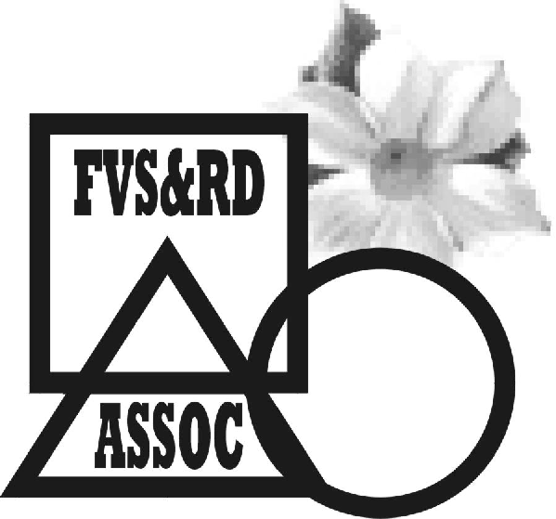
Member of the Fraser Valley Square & Round Dance Association
For more information contact:

Insert you contact
information here
CLUBS:
Use this photo or replace it with one of your own photo
It’s a Social
Event!

Gen2011

